**Paradigm Pet Professional: Task 1**

A.  Using the attached “Paradigm Pet Professional UI Design Specifications” and existing “Paradigm Pet Professionals Website” from the Web Links section, compare the content, functionality, and navigation of the current website to user specifications and evaluate audience and stakeholders needs by doing the following:

1.  Describe how the current website content fails to meet audience and stakeholder needs.

* Users need healthy food suggestions for a particular cat at any stage and dog toy recommendations. The current website does not offer any suggestions for healthy food options for specific cat types at any stage or suggested dog toys that encourage play.
* Stakeholders need to know specific information about the user: user’s name, phone number, e-mail address, time zone, their pet's name, their pet's type, and their pet's age. The existing website does not offer a method for users to input the information required.

2.  Describe how the current website functionality fails to meet audience and stakeholder needs.

* Users need an outline of the company, and the current website does not state the company slogan, brand values, and services on the home page.
* Stakeholders need to encourage one-on-one consultations with Pexperts for additional well-being questions. The existing site does not offer a way for users to confer with Pexperts.

3.  Describe how the current navigation system fails to meet audience and stakeholder needs.

* Users need the information to be easily identifiable and compatible across all devices. The current website provides a Fetch button and tabs within a navigation bar across the top of the page that is hard to read on a mobile device.
* The stakeholders need the site to be readable and easy to navigate. The current website provides a Fetch button and tabs within a navigation bar across the top of the page that is hard to read on a mobile device. The highlighted tab does not match the tab selected. Also, the Fetch button is inactive when clicked after search input.

B.  Determine the information architecture for the new website based on the attached “Paradigm Pet Professional UI Design Specifications” by doing the following:

1.  Explain the necessary website functionality and micro interactions needed to meet audience and stakeholder needs.

* Users need links to pages within the website. I will include in-site search links to the photo gallery of cats, dogs, and birds on the home page that allows the user to click through a series of pictures. This new function will consist of a micro-interaction that can hover over any image in the gallery and see options for animal care or a recommended Pexpert.
* Stakeholders need the website to be easy to navigate. I will create an in-site search that allows users to have access and locate specific information on a page as the website grows. This new function will consist of a micro-interaction with the capacity to scroll up and down the web page so the user can view all information available.

2.  Describe the type of content that will be used for **one** new page based on **one** of the new user personas, including how the elements of the content align directly to the chosen user persona.

* Users need a desktop view of the information on the relational requirements of their birds to guarantee suitable welfare. I will create a bird page that will give a descriptive paragraph on the three common causes of depression which are the following: physical and cognitive ailments, growing boredom, and loss of a companion. In addition to the paragraph, I will create a bullet list of four signs of depression in birds which are the following: decreased hunger, escalating irritability, hostile behavior, and singing songs of a graver tone. This page will be compatible across all devices.

3.  Identify existing content from the website that will be removed or redeveloped and explain how that content fails to meet the proposed audience and stakeholder needs.

* Users need bird photos, and the current site only has cat, dog, and snake photos. I will remove the snake photos and the FAQs link. I will replace them with bird photos with a Bird link to better meet the user's needs.
* Stakeholders need content to provide pet care advice. The site only has information on cats, dogs, and FAQs. I will remove the snake photos and the FAQs link and replace them with bird photos, Bird link, and bird tab to access bird care advice. Doing so will fulfill the stakeholder requirements.

4.  Create a visual sitemap to determine the structure and the hierarchy of the site content, including the following:

•  a home page

•  a page for each existing pet page

•  a new page for the new user persona you identified in part B2

5.  Explain how your information architecture meets audience and stakeholder needs.

* Users need a company overview on the home page. The stakeholders need constant branding that defines their ethics. I will make a page committed to this subject and include a noticeably classified link to the primary navigation. At the top of every web page of the website will be the navigation bar. Doing so allows the home page to be located with ease from anywhere on the site. On the home page, the user will see the company outline, the brand by stating the company slogan, brand values, services, and business brand logo on every web page.
* Stakeholders need a website that is simple to navigate and offers pet care advice. Users need to locate information with ease on dog lifetime activity needs, benefits of physical activity, and toy recommendations. I will create a page dedicated to this subject and include a visibly classified link to the primary navigation. At the top of every web page of the website will be the navigation bar. Doing so allows the dog page to be located with ease from anywhere on the site. The users will find information on the lifetime activity needs, benefits of physical activity, and toys suggestions on the dog page.
* Stakeholders need a simple-to-navigate website that offers pet care advice. Users need to simply locate information on specific cat feeding based on their type, age, diet, other preferences, and healthy food recommendations for any stage. I will form a page committed to this subject and add a visibly classified link to the primary navigation. At the top of every web page of the website will be the navigation bar. Doing so allows the cat page to be located with ease from anywhere on the site. The users on this page will find information about specific cat feeding based on their type, age, diet, other preferences, and healthy food recommendations for any stage.
* Stakeholders need a simple-to-navigate website that offers pet care advice. Users need to simply locate information about birds and their relational needs to guarantee suitable welfare. I will form a page committed to this subject and add a visibly classified link to the primary navigation. At the top of every web page of the website will be the navigation bar. Doing so allows the bird page to be located with ease from anywhere on the site. The users on the birds’ page will find information about birds and their relational requirements.

6.  Explain the primary and secondary navigational elements required to support the information architecture.

a.  Explain how these primary and secondary navigational elements each align with audience and stakeholder needs.

* The primary navigation element will be the navigation bar and its tabs. Users need to easily locate information about healthy cat food options, dog toys, or bird relational needs by setting this across the top of every page on the website. That will ensure that the tabs named cats, dogs, and birds are linked correctly to the readily available information.
* The secondary navigation element will be the search bar. Stakeholders need a simple-to-navigate website. The search bar allows access to external information apart from the primary navigation.

C.  Determine page layout by creating a mid-fidelity wireframe for the home page that is sized for a desktop website that includes each of the following:

•  site header, including the branding elements

•  site footer

•  primary and secondary navigational elements

•  placeholder text and placeholder images

•  specific components needed (buttons, links, form fields, search bar, etc.)

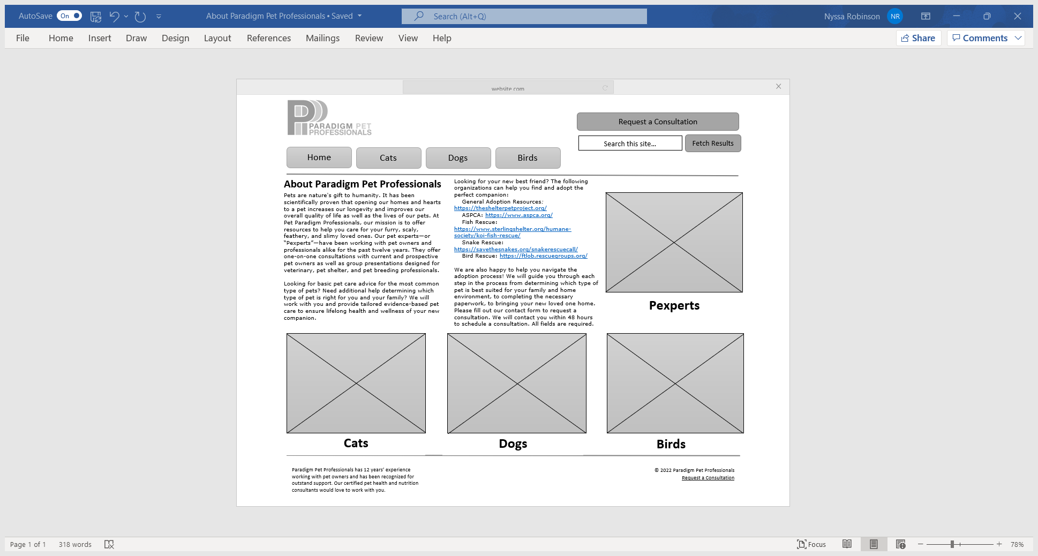

D.  Develop a detailed maintenance plan for the responsive website that aligns with stakeholder needs outlined in the attached “Paradigm Pet Professional UI Design Specifications,” include one maintenance task for each of the following:

* Task 1: efforts to ensure universal accessibility to all site content
* Task 2: the relationship between written content and SEO
* Task 3: tasks required to properly maintain the website
* Task 4: plan for rendering the website on desktop and mobile devices
* Task 5: SEO strategies for mobile devices

|  |  |  |
| --- | --- | --- |
| Task 1 | Task 2 | Task 3 |
| * Task: Accessibility Check * Domain: Performance and User Feedback * Target: HTML code * Owner: Web Developer/Quality assurance tester/User Feedback * Timing: Quarterly/Yearly * Assets: WCAG, Keyboard and the User   Stakeholders need the website to meet accessibility standards. | * Task: Website Optimization Check * Domain: Functionality * Target: HTML code * Owner: Information Architect and Web Content Specialist * Timing: Monthly * Assets: Keyword tools and Web Server access   Stakeholders need the website to be on the first page of search engine results when searching for “new pet consultants” and “new pet care consultants”. | * Task: Website Maintenance Check * Domain: Functionality * Target: HTML, JavaScript, and Webserver Technology * Owner: Server Administrator * Timing: Weekly/Monthly * Assets: Web server access   Stakeholders need the website to be checked for errors and updates to ensure a great experience for users which will aid site expansion. |

|  |  |
| --- | --- |
| Task 4 | Task 5 |
| * Task: Desktop and Mobile Device Rendering Check * Domain: Performance * Target: HTML, CSS, and Metadata * Owner: Information Architect and Web Content Specialist * Timing: Monthly * Assets: Responsive Web Design and Meta Viewport tag   Stakeholders need an ideal experience that is compatible with all devices. | * Task: Mobile Friendliness Check * Domain: Performance * Target: CSS and JavaScript code * Owner: UX, UI, and Web Developer * Timing: Monthly * Assets: Responsive Web Design and Configuration   Stakeholders need the website to meet the one-year site goals of 100,000 new visitors and 150 new consults. |